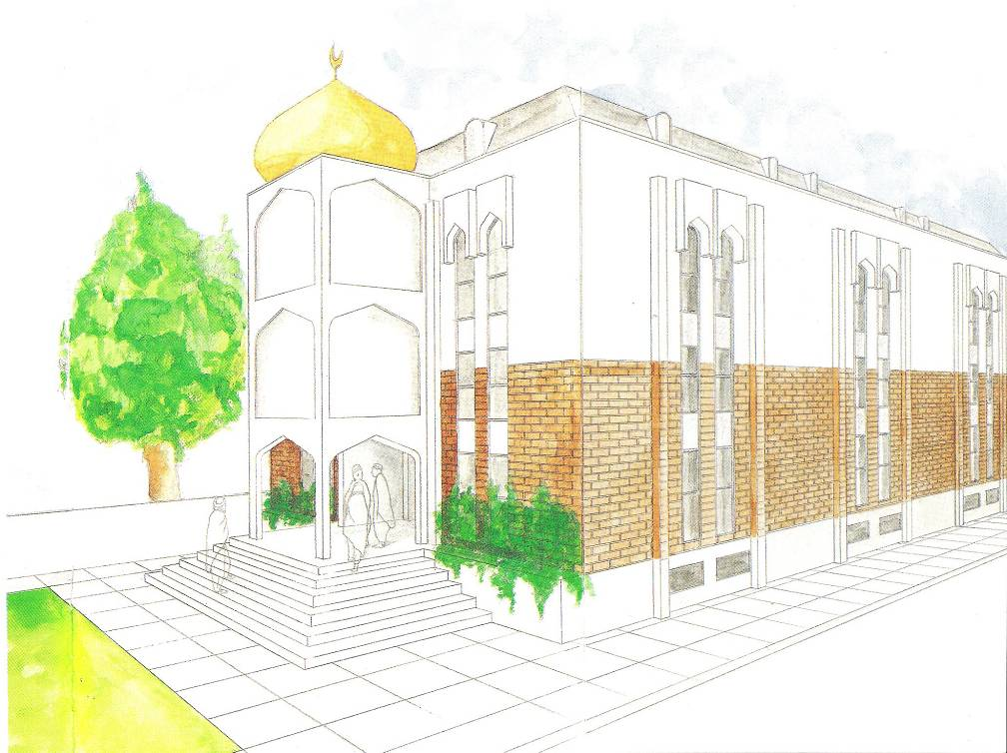
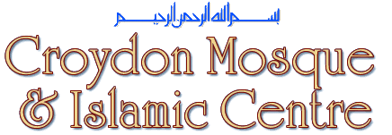

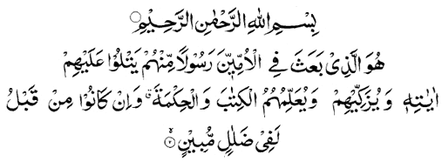

‘It is He Who has sent amongst the Unlettered a Messenger of their own, to recite unto them His revelations and to make them grow, and to teach them the Scripture and Wisdom, though they were indeed in manifest error.’
(Surah Jumu’a: Verse 2)

Introduction
Alhamdulillah, with Allah’s help, we now have a fully functioning Mosque and Islamic Centre with the generous co-operation of our local community as well as our brethren abroad. The Mosque has a full-time imam, a caretaker, and teachers. Above all, the assistance of many volunteers has been paramount to the success in the smooth running of the Mosque. However, the need to cater for the increasing Muslim population in the area has arisen and therefore our plan is to compliment the current building with a new extension: Phase 3. The existing Mosque building has been used to meet the needs for Sisters’ activities; but the demand has far exceeded all our expectations and the building is now inadequate and does not allow further expansion of such activities. Phase 3 will provide a fully segregated Sisters area for the purpose of worship, activities and circle.
The Muslim population of Croydon is approximately 26,000; of which 22,000 are registered Muslims and the rest is made up of foreign students and visitors. The need for an extension to the current building can hardly be over emphasised. The Croydon Islamic Centre recognises the need to provide the teachings of Islam to Muslims and non-Muslims alike.

Current Needs
Increasing Muslim Population - Our overwhelming need is to cater for the increasing Muslim population in the area. There has been an increase in Muslim immigrants, from all walks of life, entering the Croydon and surrounding areas.
Fully Segregated Sisters’ area - Sisters Islamic circles are sometimes held at their homes. Currently there is no fully-segregated female-only building in the local area.
Dedicated Janazah room – CMIC on average have one janazah a week. To cater for this a dedicated and better equipped Janazah room is required.
Reduce risk of the basement flooding by moving the current wash areas and WCs from the basement to above ground level in the new building
Better equipped ablution areas, WCs and specialist disabled WCs.

Education
The children are taught to read the Qur’an and Sunnah as well as understanding the principles of Islam. At the moment various children are taught in open plan halls, which are unsuitable due to the distraction from the adjoining groups. However, separate purpose built classrooms will provide a good environment for learning.
In addition to teaching Muslim children we have a duty to inform non-Muslim members of the society in which we live about Islam. It is our intention that the Centre will be a major source of information in South London, with a comprehensive library, equipped with a reading room, and books available for both loan and purchase. Schools and other educational institutions in Croydon will be encouraged to avail themselves of our facilities in learning about Islam. Various lectures and seminars will also be arranged, open to Muslims and non-Muslims.
Attendance at Islamic course
400 Muslim children attend daily and weekly classes
20/50 Youth attended our Saturday Evening Lectures provided by our Imam’s and Scholars
900 pupils from local schools were given an introduction to Islam
GCSE subjects tuition service provided
Youth Projects
We are determined that our youth should receive guidance in order that they grow up as responsible members of our Community. The Mosque already organises both Cricket and football teams that participate in local leagues. Self defence and keep fit classes are also conducted on a regular basis in the existing building. The Centre also hires extra facilities, such as School halls for Indoor sports. We also encourage the youth to attend national camps to broaden their horizons.
We are committed to continuing our existing youth projects and develop further activities.

SISTERS GATHERINGS
Croydon Mosque is the first masjid in the South London area to provide basic facilities for Sisters. Weekly circles and Monday Taleem (Lessons from the Qur’an and Sunnah) has proven to be very popular, along with the Sisters prayer area which is open for the five daily prayers, Taraweeh, Jummah and Eid. Sisters attend the masjid very regularly. For example, 100-150 Sisters attend the Taraweeh prayers daily. We endeavour to provide better facilities for our Sisters by providing a fully-segregated area in Phase 3.

Senior Citizens
The large turn-out at recent luncheons confirms that there is a demand for a central meeting place. As our community members grow older their need for social interaction grows, and the proposed Centre will serve this need. It is hoped that free meals and snacks be provided.
Religious and Social Needs
At times of Peak demand the existing Mosque cannot cope with the Number of people coming to prayer. We find this a particular difficulty on Friday prayers, especially during school holidays, and also at Eid. Regrettably, in the past, people have had to be accommodated in the car park.

6,000 – 8,000 people attend the masjid on Eid day
800 – 1,000 males attend the masjid during daily Taraweeh prayers in Ramadhan
100 – 150 females regularly attend the Taraweeh prayers and the speeches that follow
70 % of the attendees in Friday
prayer are working class people

We also currently lack facilities to accommodate the large gatherings at weddings. We intend to provide open plan halls to accommodate these events. A kitchen will also be provided to cope with the catering needs.
LOCAL SUPPORT & FUNDING
Opportunity to Build - Unlike other mosques in the locality who are restricted in terms of expansion, we are fortunate to have no restrictions to expand this part of the building
Donations & Loans - Many people and local businesses are willing to donate and/or provide Qardh-e-Hasanah for around £100k - £200k for this noble project
Management Investments - The current management team and trustees, who have purchased two properties during their time in office, are excellent investments in providing further funds for the day to day running of the masjid
Parking arrangements - Local businesses including the neighbouring hotels and the Mayday Hospital have offered us full use of their parking areas on Jummah, Eid and special occasions
Lower Construction Costs - Due to the current global financial crisis, the costs of construction is lower in this current climate Labour costs will be at the lowest for many years. This opportunity should not be missed as the cost of material is rising daily Savings can be used to refurbish existing parts of the building. To maximise savings, building work should begin as soon as possible

CURRENT & Proposed CAPACITY FIGURES
Existing
Phase 1 600 – 650
Phase 2 1,100 – 1,150
TOTAL: 1,800 (Friday/Eid: 2,000)
Proposed
Moving Wudu/WCs areas 150
Phase 3 450 – 500
PROPOSED TOTAL: 2,450 (Friday/Eid: 2,750)

Capacity of Neighbouring Mosques
Norbury Islamic Academy 220
Norbury Afghani Mosque 40 – 50
Thornton Heath Islamic 300
Norwood Mosque 300
Bangladeshi Mosque 50 – 70
Al Khair Foundation 100 – 150
Proposed Development
It is proposed that Phase 3 will be a three storey extension to the existing building where the car park is currently located. The floor space is intended to be used as follows:
Ground floor
- Car parking space for Imams
- Janazah room
- Toilets and Wudhu facilities
- Disabled Toilets
First floor
- Open plan multi-purpose hall
- Toilets and Wudhu facilities
- Disabled Toilets
Second floor
- Open plan multi-purpose hall
- Toilets and Wudhu facilities
- Disabled Toilets

FUNDING REQUIREMENT
BUDGET £ STAGE
Professional Fees 20,000 1
Sub-Structure (Piling,etc) 33,480 2
Preliminaries 15,000 3
Superstructure 65,000 4
M&E Services 40,000 5
Drainage & Utilities 45,000 5
Flooring 30,000 5
Roofing & Guttering 30,000 5
Brick/Blockwork 40,000 5
Lift & Stairs 20,000 5
Finishing -
Flooring 12,000
Windows, doors 22,000 6
Decorating 7,000 6
Internal Ceiling & Walls 35,000 6
76,000
414,480
Contingency - 6% of Build Cost 24,869
TOTAL ESTIMATED COSTS 439,349
Current Facilities
- Madressa Classes
- Adults Classes: Arabic, Quran and Tuition
- Janazah Services
- Circumcision Facilities
- Islamic Nikah and Civil Marriage Registration
- In-house Mufti and Imam offering Islamic advice to scholars and the general public
- Legal Advice Service: Offering advice in Shariah & State laws
- Medical and Police surgeries held regularly
- Teacher Training Centre
- Website and instant email announcements service
- Educational seminars, lectures and masjid tours
- Sets Islamic standards and framework for other masjids
- Lead Promoters in the Islamic Science of Moon Sighting
Facts
Croydon Mosque and Islamic Centre is…
- the largest Masjid in South London
- one of the three mosques in Surrey and the surround areas; the others are Sutton and Crawley
- a role model mosque as recently publicised on Islam Channel’s show ‘Model Mosque’. CMIC became the show’s finalist in 2007
- one of the few purpose built mosques in London
- the first masjid in South London to allocate permanent prayer facilities for women
Please contribute to make this a Reality
Living in a western society makes it difficult to maintain our Islamic values. At the same time we are duty bound to inform our host community about Islam. These needs can be met by providing a purpose built Centre. However, the current funds are inadequate to embark on this much needed and long overdue project.
This outstanding project can only be accomplished with your help!
Contribute now and your generous donation will serve generations to come.

HOW TO DONATE
You can donate by any of the following methods
- Donations direct to the Mosque
- Gift Aid so that income tax may be reclaimed
- Direct Payment to:
National Westminster Bank Plc,
Norbury Branch, 1393 London Road,
Norbury, SW16 4XF
Account Name:
Croydon Mosque & Islamic Centre
Sort Code: 60-15-16
Account No: 02848988

MAY ALLAH REWARD YOU MANY FOLDS FOR HELPING THIS WORTHY CAUSE. AMEEN.

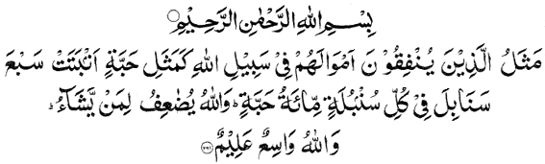

‘The likeness of those who spend their wealth in Allah’s way is as the likeness of a grain which groweth seven ears, in every ear a hundred grains. Allah giveth increase manifold to whom He pleases. Allah is All-Embracing, All-Knowing.
(Surah Al-Baqarah: Verse 261)
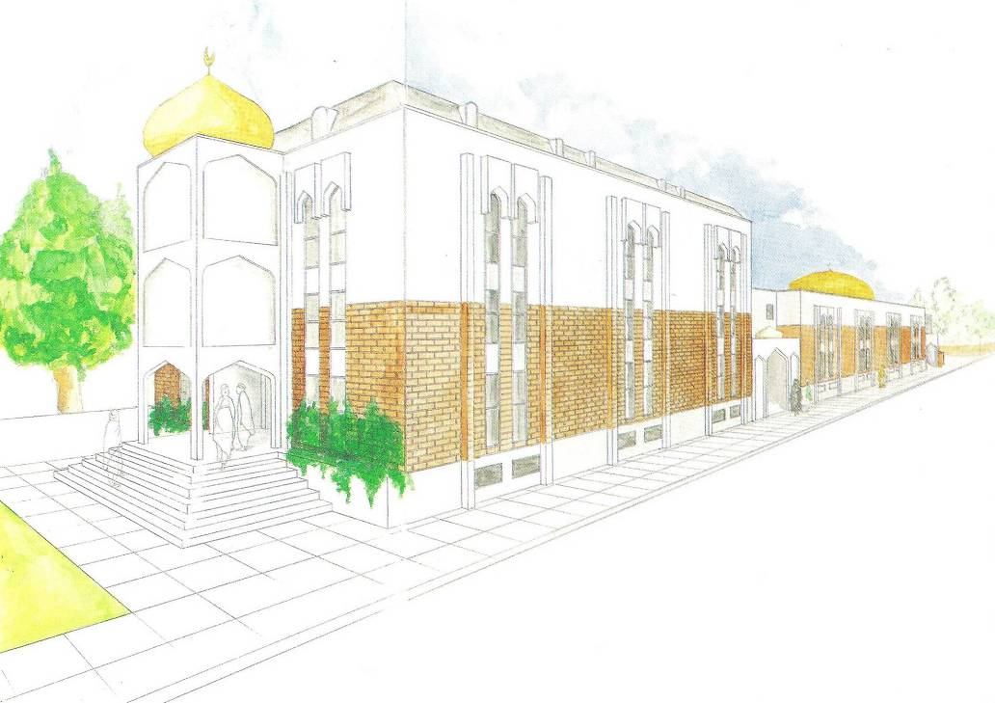
CROYDON MOSQUE & ISLAMIC CENTRE
525 London Road, Thornton Heath, Surrey CR4 6AR (UK)
Tel/Fax: +44 (0)20 8684 8200
Web: www.croydonmosque.org
Registered Charity No. 285030

